***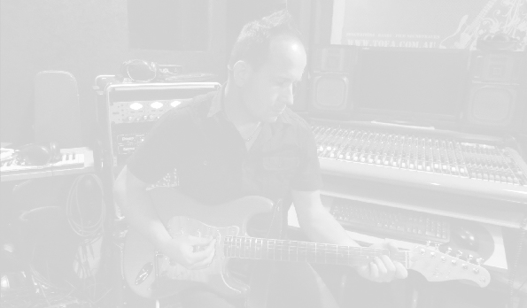*C h r i s t o p h e r   S p r a k e  - B i o g r a p h y**

**Short form:** Christopher Sprake is a Melbourne based singer, song writer and producer.

**As a performer** and recording artist he has toured Australia and North America. His recordings and video clips have received airplay in Australia, North America and Europe.

**As a producer** he has worked with countless Melbourne singers and musicians and has also produced for internationally released artists such as Steve Roach and little rain, Sandra Maoirana and Neple’.

**As a community music advocate** he has produced and mentored hip hop crew Nu Regime, recorded and co-ordinated “Music from the heart” (a compilation c.d. and live event featuring music groups from every neighbourhood house in the City of Yarra) and regularly runs music events and festivals on the Richmond and Collingwood public housing estates.

**Long form: After fronting a string of bands** in the ‘90s, 2000 saw Christopher performing solo under his nickname “Tofa”. First touring Canada in 2000, Chris received a warm welcome from audiences and radio alike. More recordings showcased the more intimate song writing that has become the trademark of his live show. The 2003 single "So Beautiful" drew glowing reviews from street press, being described as **"Lush acoustic pop that makes you wanna go back and listen a few more times" “an obsession with pretty aesthetics"(INPRESS magazine)** Community radio showed great support for the single, and the video clip screened on the Australian national music television program RAGE, with later screenings on Much Music Canada and Sky Europe. Christopher toured with the single, the final hometown show doubling as a launch for the Metanoia Multi-arts co-operative and a benefit for the East Timorese refugee community of Richmond.   
Christopher’s 2004 release "Winter upon us" was a potent snapshot of his song writing that has been described as "charged with haunting, raw edged emotion" and reviewed as **" ...finely crafted, with a subtle layering of sound..." (Ron Burd, MD, CIUT-FM Toronto)** "Seashanty" was the next single, and featured an accompanying video clip produced by Melbourne Independent movie maker Andrew Lee. The combination of unique animation and the melodic acoustic tune resulted in the song being screened on national and community television programs and played on community radio in Australia. The video clip was also added to rotation " Much Music" Canada and Sky channel Europe.  
In 2006 viola player Jocelyn Evans began working with Chris and contributed to three songs for a new e.p. The Launch of the “Other Places” e.p. was once again a sell out, and great radio support followed. Over the next few years Christopher performed with a new band line up under the name “The Autumn Sails”. Christopher’s writing moved into a darker indie folk style, and the debut self titled album was accepted by the Australian government program AIRIT for distribution to radio across Australia. The video single “All Nations” screened on Australian music television, and an east coast tour and home town album launch followed. In 2013 Christopher released a new solo EP “Firebird” signalling another shift in his development as an artist. Praise for Firebird ~ **“Letting the music speak, Christopher Sprake tells stories that burn a memorable experience that will let one’s soul fly. An EP that deserves the title of mini-album…23 minutes of escape, with licks of early REM, back to a time when lyrics mattered” (John Murch, Broadcaster)**  In 2014 Christopher began working with a new band line up and released the vinyl single and video clip for “Dead Star” while returning to local shows. He also returned to Canada in late 2014 to work with Canadian producer / musician Jim Bryson on a new (as yet unreleased) E.P. Spending much of 2015 writing with the new band, “Made Ghosts” was released in August and signalled a shift in sound to his indie rock roots…Christopher now divides his time between his performing / recording, and his producer / engineer role at **Last Match Recordings. He is a strong advocate for community music programs across inner city housing estates.**